A PROJECT REPORT ON
CLINICARE
(A Primary Health Care Web Application)
Submitted By
TEAM BUSY-BEES
Vikas P (NEC 09 14 050)
Vishnu K N (NEC 09 14 051)

June 2017
Submitted in the fulfillment of the requirements of the Award of
Diploma in Information Technology


NETTUR TECHNICAL TRAINING FOUNDATION
#40/40A, Electronic City,
Hosur Road, Bangalore-560 100
NETTUR TECHNICAL TRAINING FOUNDATION
#40/40A, Electronic City,
Hosur Road,
Bangalore-560 100.
CERTIFICATE
This is to certify that the project work titled “CLINICARE” has been successfully completed in the fulfillment of the award of Diploma in Information technology offered by NTTF during the academic year 2014-2017 and that this report is documentation of the same.

Project Guide Course In-charge Principal

Name of the Examiner’s Signature with date
1.
2.

SYNOPSIS
Introduction

In today's World We have many tourists visiting our cities and also there are people coming for work in Our City . There happens some emergency situations where these people may need the Medical Assistance .Our CLINICARE is the best solution for such people in Bangalore who need immediate Medical Guidance.

The CLINICARE is an On line Medical Assistance where people can gather information about the Medical Supports near them.

ACKNOWLEDGMENT

An endeavor of this magnitude is never accomplished in isolation. We are deeply indebted to a number of people notably :
First of all we are thanked to Mr. Giridharan R, Principal NTTF Training Center NEC- Bangalore and Mr. Palani Kumar, Vice-Principal NTTF Training center NEC- Bangalore for being a source of inspiration throughout our project.
We owe great to Mr. Ramkrishnanand, Academic In-charge in the project work.
We are indebted and grateful to Mrs. Rijina P, Our Project In-charge, Our Project Guide Mrs. Prabha and Mr. Shakeel, Our Subject-In charge , guide for valuable guidance at each and every stage of Our Project.
With deep sense if gratitude We express Our heartfelt thanks to Mrs. Deepa, Mrs. Soumya, and all other Staff Members who gave valuable suggestions and constant encouragement for successful fulfillment of the project.
Finally we thank one and all who helped us in directly and indirectly for the completion of the project.

CONTENTS
- Introduction

  - Title of the project
  - Group Name
  - Group Leader
  - Group Members
  - S/W & H/W Configuration
  - Technology used
  - Project Description
  - Project Modules
  - Project Plan

- SRS Document

- System Design

  - Control Flow Diagram
  - Data Flow Diagram
  - Entity Relationship Diagram
  - Use Case Diagram
  - Database Design
  - Data Dictionary
  - Gantt Chart
- Snapshots

- Source Code

- Reports, Test plan, Test case, Bug Report

- Future Enhancements of Project

- Bibliography

- Conclusion

1. INTRODUCTION
1.1 TITLE OF THE PROJECT : CLINICARE

1.2 GROUP NAME : BUSY-BEES

1.3 GROUP LEADER :

1.4 GROUP MEMBERS :

Vikas P (NEC 09 14 050)
Vishnu K N (NEC09 14 051)

1.5 S/W & H/W CONFIGURATION

SOFTWARE REQUIREMENTS:

Front End  JSP, HTML5, CSS
Database  MySQL
Scripting language  J query, Bootstrap
Web Server  Apache-tomcat Server 6.0
Operating system  Windows-8.1or
Above
IDE  Net Beans 8.1,
Notepad++
Third Party Software  Twilio SMS Gateway
Social Services  G mail Services for sending mail
Browsers  IE8/8+, Chrome15+,
Safari 4+,
Mozilla Firefox

HARDWARE REQUIREMENTS:

Processor : Intel i3 and above
RAM : 2 GB and above
Hard Disk : 500 GB and above

1.6 TECHNOLOGY USED

J2EE, JSP, HTML5, MySQL

1.7 PROJECT DESCRIPTION

The Project CLINICARE is a complete medical assistance where the user can approach our web application to enroll in complete Medical Guidance in the Cities of Bangalore.

The Main Objective of our CLINICARE is to guide the people who are new to the city to any medical centers in case of emergency. Also people will get information about certain medical camps conducts by charitable, hospitals etc.

1.8 PROJECT MODULES

The modules present in CLINICARE are:
ADMIN:
LOGIN
VERIFY DOCTOR AUTHENTICATION
EDIT/UPDATE MED CAMPS
EDIT/UPDATE BLOOD DONORS
LOG OUT
USER:
TAKE DOCTOR APPOINTMENTS
VIEW BLOOD DONORS
ADD BLOOD DONORS
VIEW SERVICES
VIEW MED CAMPS
INFORM MED CAMPS
DOCTOR: LOGIN
VIEW APPOINTMENTS
UPDATE LEAVE
LOGOUT

Module Description:

APPOINTMENTS:
In this module the user can take the doctor's appointment nearby their location. To take the appointment the user should fill up and submit the Registration form with their mobile number and when they finish their appointment, a message with the time and schedule of the appointment will be sent to their mobile phone.

BLOOD BANK:
This module gives the detail about the blood donors. The users can view the nearest blood banks and the blood donors by selecting the location and the blood group. The module also has a registration for the users who are willing to donate their blood.

DOCTOR'S LOGIN:
This module is for Doctors. The Doctor Should Login with the login credentials issued by the Admin. Once they login they can View the Appointments of the day, the doctors can update their leaves and Update and Edit their records.

SERVICES:
The module is about the details of Medical Stores and the Laboratories near your location .Users can also find the Ambulance Service in this Module.

MEDICAL CAMPS:
Users can see the details of free check up and medical camps in the City. The Module also has the facility to upload or inform details of any upcoming Medical camps.

JSP:
- JSP pages are components in a web or J2EE application that consists of HTML and Java code

- Code in a JSP can access data across the entire web application and can use server-side resources such as databases, directories, and other application components.

- JSP pages are dynamic because they can contain Java code, which can process the request and tailor the response based on the request. All the power of Java sits behind every JSP page.

- JSP is easy to learn and allows developers to quickly produce websites and application in an open and standard way. JSP is based on Java, an object oriented language. JSP offers a robust platform for web development.
Main reasons to use JSP:
- Multi-Platform.
- Component reuse by using Java Beans and EJB.
- Advantages of Java.

MySQL:
MySQL is a database which helps us to store data in large amount and retrieve when required. It is major used for the server side storage in most of the project which also take cares with the security by login.
This also easy to create, update, delete, insert and perform other operations when required easily. The database created can be easily taken as back up and restored in any place again and executed. Backup of information can be taken in the MySQL.
The Oracle relational database management system (RDBMS) provides an open, comprehensive, integrated approach to information management.
This is accomplished while delivering high performance. At the same time, it prevents unauthorized access and provides efficient solutions for failure recovery.

TESTING:
Testing must be done with proper planning as the system testing is very expensive for large systems, huge amount has spent for testing.
Test planning is concerned with setting out standards for the testing process, rather than describing product tests. Error may begin to occur the very inspection of the process whether the objectives may be imperfectly specified, as well as later design and development stages.
After the source was ready, the application was tested to uncover as many errors as possible. Tests were conducted to:
- Examine the internal logic of the application components/Elements.

- Examine the input and output domains of the program to Uncover errors in the program functions and performance.

2. SOFTWARE REQUIREMENT SPECIFICATION (SRS)
Advantages:
- Users can easily locate clinics and take the doctor appointment
- Medical assistance in major locations
- Information of Medical camps
- Users can search and find blood donors in their location

Purpose:
Clinicare is a web application for the
people to locate and find out the nearest clinics, blood donors and medical stores and laboratories.

Scope :
There is no existing application like
Clinicare. The only existing applications are
hospital management system, which can
only give access to the availability with in
that hospital.

Drawbacks :
- In such hospital management systems,users can only take appointment for the
doctors available in that particular
hospital.
- Medical details will be limited within the particular hospital.

3. SYSTEM DESIGN
3.1 BLOCK DIAGRAM (BD)

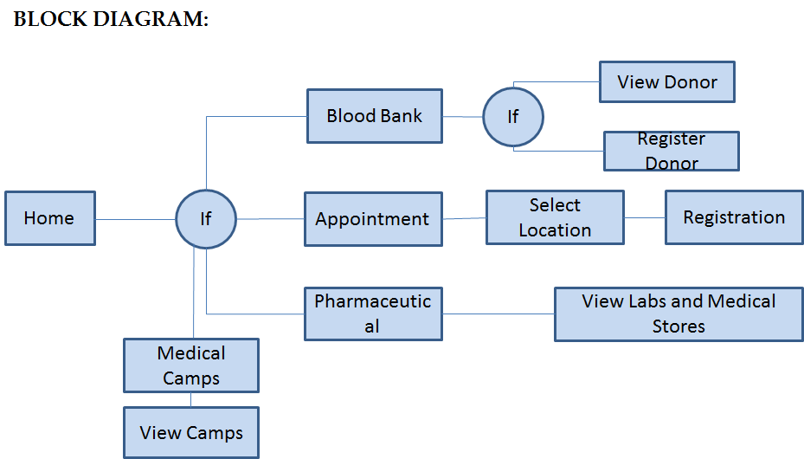

3.2 DATA FLOW DIAGRAM (DFD)
USER DFD
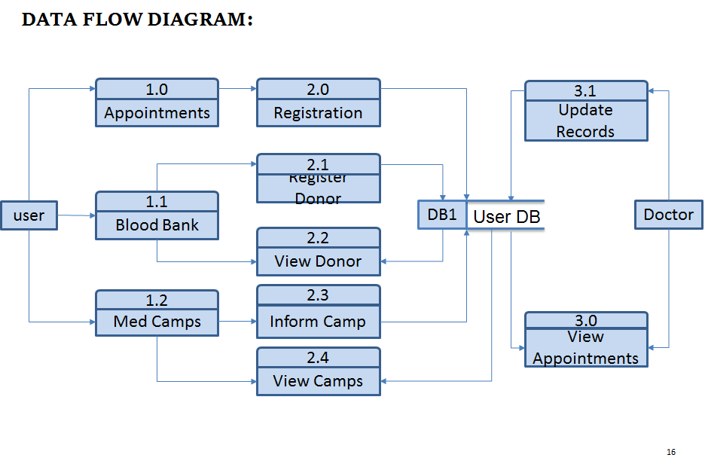

3.3 ENTITY RELATIONSHIP DIAGRAM

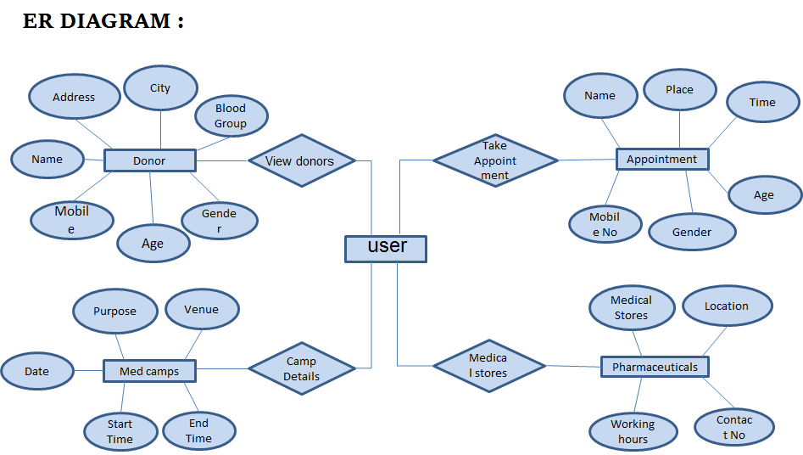

3.4 USE CASE DIAGRAM:

USER DIAGRAM:
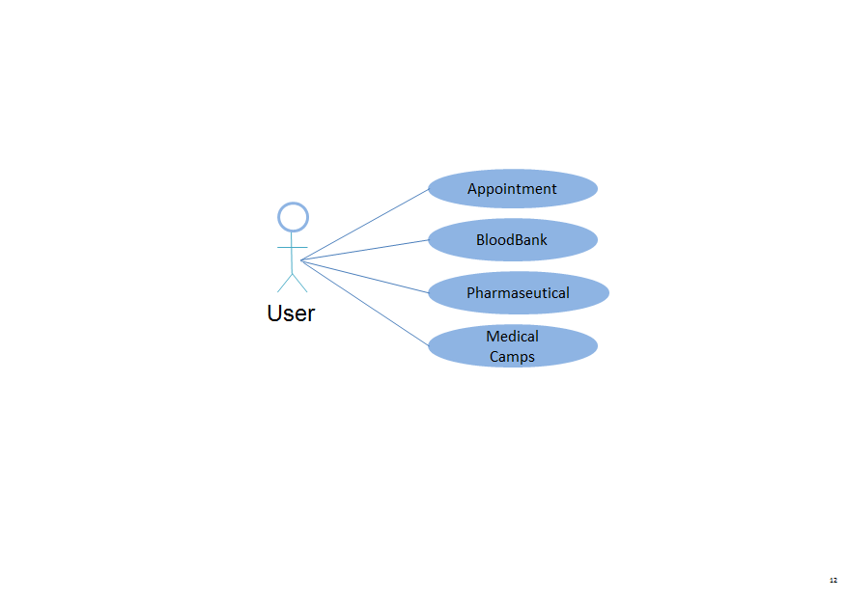

ADMIN DIAGRAM:

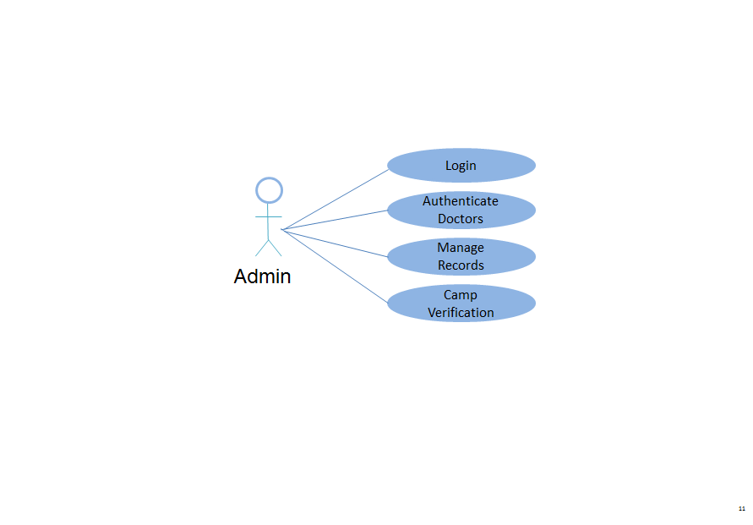

DOCTOR DIAGRAM:

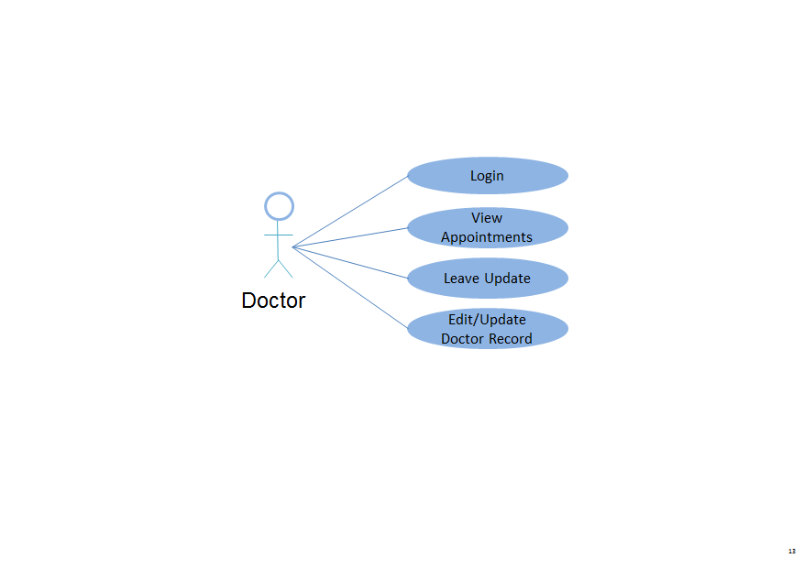

3.5.DATABASE DESIGN

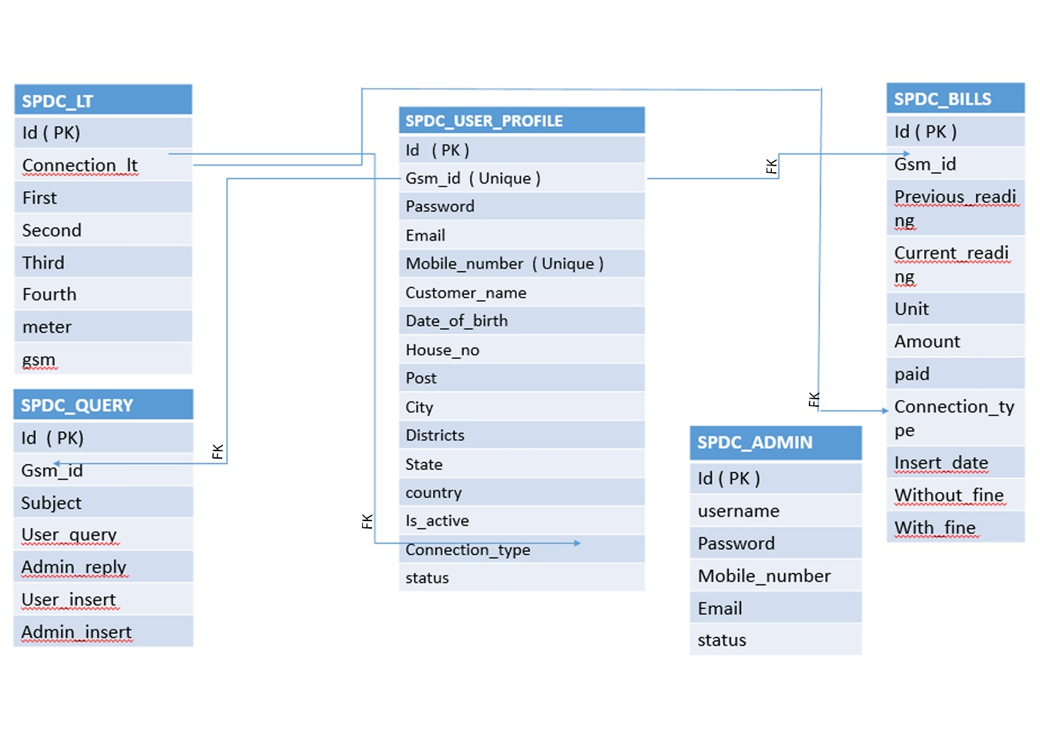

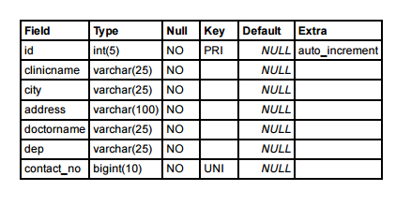
3.6.DATA DICTIONARY

CLINIC TABLE

DOCTOR_LOG TABLE

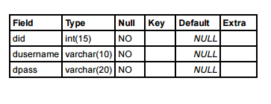

DOCTOR TABLE
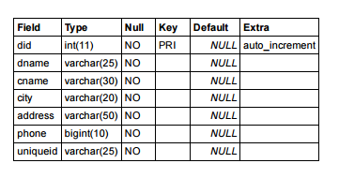

LIST DONOR
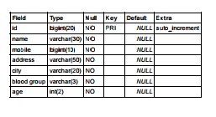

MED CAMPS TABLE

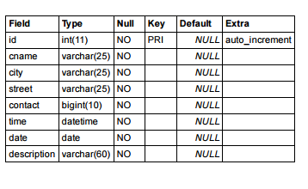

PATIENTS TABLE
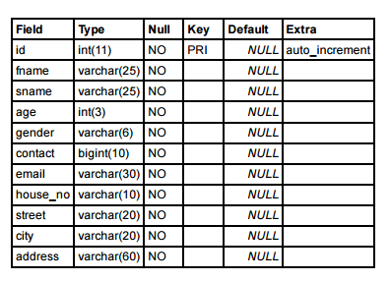

3.7 GANTT CHART

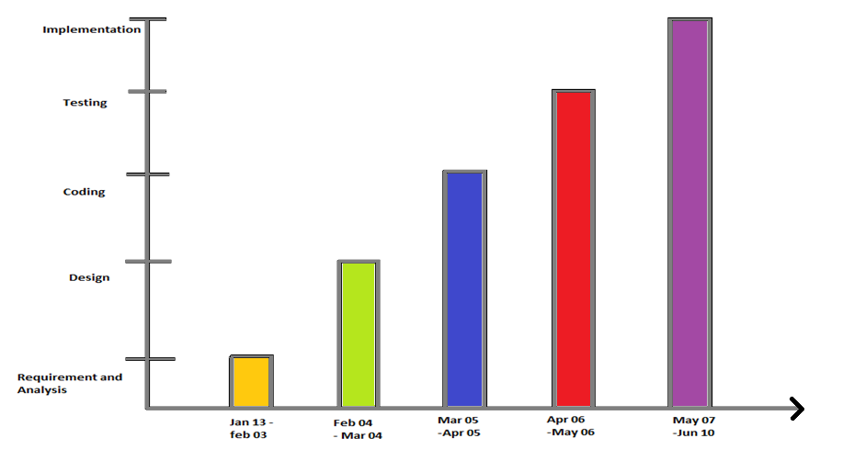

4. SNAPSHOTS

5.SOURCE CODE
- Main Web Pages

Clinicare_Home.jsp

<%@page contentType="text/html" pageEncoding="UTF-8"%>

<!DOCTYPE html>
<html lang="en">
<head>
<meta charset="utf-8">
<meta name="viewport" content="width=device- width, initialscale=1">

<title>cliniCare</title>

<link rel="stylesheet" type="text/css" href="https://fonts.googleapis.com/css?family=Open+Sans|Raleway|Candal">

<link rel="stylesheet" type="text/css" href="bootstrap/css/font-awesome.min.css">

<link rel="stylesheet" type="text/css" href="bootstrap/css/bootstrap.min_1.css">
<link rel="stylesheet" type="text/css" href="bootstrap/css/style_1.css">
</head>

<style>
#dbtn{ height:40px;height-top:10px;}
#banner{
background: url('img/bg-banner.jpg') no- repeat fixed;
background-size: cover;
min-height: 650px;
position: relative;
}
</style>

<body id="myPage" data-spy="scroll" data-target=".navbar" data-offset="60">

<section id="banner" class="banner">

<div class="bg-color">

<nav class="navbar-default navbar-fixed-top">
<div class="container">
<div class="col-md-12">
<div class="navbar-header">

<button type="button" class="navbar-toggle" data-toggle="collapse" data-target="#myNavbar">

<span class="icon-bar"></span>
<span class="icon-bar"></span>
<span class="icon-bar"></span>
</button>

<a class="navbar-brand" href="#"><img src="img/clini2.png" class="img-responsive" style="width: 140px; margin-top: -16px;"></a>

</div>

<div class="collapse navbar-collapse navbar-right" id="myNavbar">

<ul class="nav navbar-nav">
<li class="active">
<a href="#banner">Home</a>
</li>

<li class="">
<a href="services.jsp">Services</a>
</li>

<li class="">
<a href="bbank.jsp">Blood Bank</a>
</li>

<li class="">
<a href="medcamps.jsp">Med Camps</a>
</li>
<li class="">
<a href="Login.jsp" class="btn btn-info" role="button" id="dbtn">DOCTOR LOGIN</a>
</li>
</ul>
</div>
</div>
</div>
</nav>

<div class="container">
<div class="row">
<div class="banner-info">
<div class="banner-logo text-center">

<img src="img/clini.png" class="img-responsive">

</div>

<div class="banner-text text-center">

<h1 class="white">Healthcare at your desk!!</h1>

<p>Primary Health Care at Your Finger Tip<br>Stay Healthy , Take Health Care at any Time Without any Loss of Wealth </p>

<a href="appointment.jsp" class="btn btn-appo">Make an Appointment.</a>

</div>
<div class="overlay-detail text-center">
<a href="#service"><i class="fa fa-angle-down"></i></a>
</div>
</div>
</div>
</div>
</div>
</section>

<!--/ banner-->
<section id="service" class="section-padding">
<div class="container">
<div class="row">
<div class="col-md-4 col-sm-4">

<h2 class="ser-title">About Us</h2>

<hr class="botm-line">

<p>There are some emergency situations where
people may need the Medical Assistance in the city.Our CLINICARE is a best solution for such people in Bangalore.The CLINICARE is an Online Medical Assistance where the peoplecan get information about the Medical Supports near them.</p>

</div>

<div class="col-md-4 col-sm-4">
<div class="service-info">
<div class="icon">

<i class="fa fa-stethoscope"></i>

</div>

<div class="icon-info">

<h4>24 Hour Support</h4>

<p>Our cliniCare give its user 24 hours access for any facilities within the clinicare.</p>

</div>
</div>

<div class="service-info">
<div class="icon">

<i class="fa fa-ambulance"></i>

</div>

<div class="icon-info">

<h4>Emergency Services</h4>

<p>cliniCare provide all emergency services for the user where they can get the information of 24 hour services in Cities.</p>

</div>
</div>
</div>

<div class="col-md-4 col-sm-4">
<div class="service-info">
<div class="icon">

<i class="fa fa-user-md"></i>

</div>

<div class="icon-info">

<h4>Medical Appointments</h4>

<p>You can search and take appointment for the Doctors available in your location. </p>

</div>
</div>

<div class="service-info">
<div class="icon">

<i class="fa fa-medkit"></i>

</div>

<div class="icon-info">
<h4>Blood Bank</h4>
<p>cliniCare provides you a facility for the blood bank where we will provide you with the blood donors in your location.</p>

</div>
</div>
</div>
</div>
</div>

</section>

<section id="about" class="section-padding">

<div class="container">
<div class="row">
<div class="col-md-3 col-sm-4 col-xs-12">
<div class="section-title">

<h2 class="head-title lg-line">
CliniCare<br>Ultimate Dream</h2>

<hr class="botm-line">

<p class="sec-para">The Dream of Clinicare is to help the people who are new to the city and meet with an emergency where they have no idea of the medical services in that location</p>

<a href="" style="color: #0cb8b6; padding- top:10px;">Know more..</a>

</div>
</div>

<div class="col-md-9 col-sm-8 col-xs-12">

<div style="visibility: visible;" class="col-sm-9 more-features-box">

<div class="more-features-box-text">

<div class="more-features-box-text-icon">

<i class="fa fa-angle-right" aria-hidden="true">
</i>
</div>

<div class="more-features-box-text-description">

<h3>It's something important you want to know.</h3>
<p>Regular Exercising and a Small Walk after Dinner can help you Build a Stronger Stamina and a Healthy Body</p>

</div>
</div>

<div class="more-features-box-text">

<div class="more-features-box-text-icon">

<i class="fa fa-angle-right" aria-hidden="true"></i>

</div>

<div class="more-features-box-text-description">

<h3>It's something important you want to know.</h3>

<p>Strawberies have more Vitamin C than in Oranges .</p>

</div>
</div>
</div>
</div>
</div>
</div>

</section>
<!--testimonial-->

<section id="cta-2" class="section-padding">

<div class="container">
<div class="row">
<div class="col-md-2">

</div>

<div class="text-right-md col-md-4 col-sm-4">

<h2 class="section-title white lg-line"> A Few Words<br>About Us</h2>

</div>

<div class="col-md-4 col-sm-5">

Health is Our Wealth..cliniCare secure your wealth through proper primary cares.

<p class="text-right text-primary"><i>--Busy
Bees</i></p>

</div>
</div>
</div>

</section>

<!--footer-->
<footer id="footer">

<div class="footer-line">

<div class="container">

<div class="row">

<div class="col-md-12 text-center">

© Copyright cliniCare . All Rights Reserved

<div class="credits">
Designed by <a href="#">BUSY BEES</a>

</div>
</div>
</div>
</div>
</div>

</footer>
<script src="bootstrap/js/jquery.min_1.js"></script>

<script src="bootstrap/js/jquery.easing.min.js">
</script>

<script src="bootstrap/js/bootstrap.min_1.js">
</script>

<script src="bootstrap/js/custom.js"></script>

<script src="contactform/contactform.js"></script>

</body>
</html>
2.Blood Bank Page

bbank.jsp

<%@page contentType="text/html" pageEncoding="UTF-8"%>

<!DOCTYPE html>
<html>
<head>

<meta http-equiv="Content-Type" content="text/html; charset=UTF-8">

<link href="bootstrap/css/bootstrap.min.css" rel="stylesheet">

<link href="styles.css" rel="stylesheet">

<title>blood bank</title>

</head>

<style>
#u{
background-color:#F7F9F9;font-family: Microsoft New Tai Lue;
position:fixed;font-size: 15px;}
.fm{
position: absolute;
top:450px;
left:550px;
}
.search {
padding:8px 15px;
background:transparent;
width:250px;
border:1px solid grey;
border-radius: 2px;
}
.button {
position:relative;
padding:6px 15px;
left:-35px;
border:3px solid #E74C3C;
background-color:#e74c3c;
color:#fafafa
}
#txt{
color:grey;
font-family: Microsoft YaHei Light;position: fixed;
left:480px;
top:500px;
}
body{
background-color: white;
}

</style>
<body>
<div id="top"
style="background-image:url('images/02.jpg'); height:350px;">
</div>

<div id="navigation">

<ul class="nav nav-pills navbar-inverse" id="u">

<li style="width:370px;height:40px;"></li>

<li><a href="home.jsp">HOME</a></li>
<li><ahref="appointment.jsp">APPOINTMENTS</a>
</li>

<li><a href="medcamps.jsp">MED CAMPS</a></li>

<li><a href="services.jsp">SERVICES</a></li>

<li style="width:300px;height:0px;"></li>

<li><a href="dblood.jsp">I'am ready to donate blood !</a></li>

</ul>

<datalist id="locs">
<option value="Electronic city">
<option value="BTM Layout">
<option value="Madiwala">
<option value="Brigade">
<option value="UB City">
<option value="Majestic">
<option value="Koramangala">
<option value="Hebbal">
</datalist>

<div id="txt">Kindly choose your location to see the blood donors near by you.</div>

<form action="vdonor.jsp" method="post" class="fm">

<input class="search" type="text" list="locs" name="user" placeholder="Search your location..." required>

<input class="button" type="submit" value="Search">

</form>
</body>
</html>

3.View Donors Page
vdonor.jsp
<%@page import="java.sql.ResultSet"%>
<%@page import="java.sql.PreparedStatement"%>
<%@page import="java.sql.DriverManager"%>
<%@page import="java.sql.Connection"%>
<%@page import="java.io.InputStreamReader"%>
<%@page contentType="text/html" pageEncoding="UTF-8"%>
<%
Class.forName("com.mysql.jdbc.Driver");
Connection con = DriverManager.getConnection("jdbc:mysql://localhost:3306/clinicare", "root", "");
String loc=request.getParameter("user");
String qry="Select * from ldonors where city=?";
PreparedStatement ps=con.prepareStatement(qry);
ps.setString(1,loc);
ResultSet rs=ps.executeQuery();
// while(rs.next())
/* {
out.println(rs.getString(2)+" "+rs.getBigDecimal(3));
out.println("<br>");
}*
//out.println(loc);
%>
<!DOCTYPE html>
<html>
<head>
<meta http-equiv="Content-Type" content="text/html; charset=UTF-8">
<title>view donors</title>
</head>
<style>
#l{
color: grey;
font-size: 20px;
font-family:Microsoft YaHei Light;}
</style>
<body>
<br>
<h2><div id="l"> List of Peoples Donating Blood in City<div style="color:red;"><% out.println(loc); %></div></div></h2><br><br><br><br>
<div style="font-size: 15px;font-family:Microsoft YaHei Light;font-weight: bold;">
<%
while(rs.next())
{
out.println(rs.getString(2)+
"&nbsp;&nbsp;&nbsp;:");
out.println(" &nbsp;&nbsp;&nbsp;&nbsp;
&nbsp;&nbsp;&nbsp;&nbsp;");
out.println(rs.getBigDecimal(3)+" &nbsp;&nbsp;&nbsp;"+rs.getString(6)
+"<hr>");
out.println("<br>");
}
%>
</div>
</body>
</html>

6.TEST
Table of Contents:
1. Test Plan Identifier
2. Introduction
2.1 Objectives
2.2 Scope
2.3 References
3. Test Items
4. Approach
4.1 Unit Testing
4.2 Integration Testing
4.3 System Testing
4.4 Performance Testing
4.5 Regression Testing
4.6 Manual Testing
5. Item Pass/Fail Criteria
6. Suspension Criteria or Resumption Requirements
6.1 Suspension Criteria

6.2 Resumption Requirements
1. Test Plan Identifier
CLINICARE
2. Introduction
The main purpose of preparing this document “Test Plan” is to test the critical use cases and the functionalities that outline the project “CLINICARE”.
The following sections will detail the item that would be tested during the testing process, an overview will present the portions of the software that require testing and a test plan of how these features will be tested. The document will address the objectives, the scope of the document and the different testing approaches used.
2.1 Objectives
The following system test plan for the “CLINICARE” will support the following objectives:
- Identify the features of the project that need to be tested.
- Define the testing approaches that will be used during testing.
- Define the pass/fail criteria for each item that would be tested.
- Define the suspension criteria and resumption technique for the same.

2.2 Scope
The document “Test Plan” will cover all the items that need to be tested and all the test approaches involved. It will also define the pass/fail criteria for each of the item being tested.

3. Test Items
The following items will be tested during the test process:
- Registration
- Login
- Forgot password
- Change password

4. Approach
The application will be tested with all the possible inputs and would be checked for all the possible outputs. A list of test cases will be prepared for testing the application. The tester would perform black box testing that is the functional/operational testing on all the items that need to be tested. Each item would contain one or more test cases, the types of testing and critical use-cases acceptance by the system. The tester would give in the inputs to the system, and then verify that the output matches the desired output outline in the document.
4.1 Unit Testing:
In this particular testing, each module is tested alone in an attempt to discover any errors that may be present in code, which means all executable source code is subject to test. The test would include all the classes, and the forms in the code for testing. Particular advantages and disadvantages of unit testing are: Advantage: that the total system is subject to testing and each module will thus be tested. Possible Disadvantage: Because of the system size, it is possible some errors might be missed and not identifies.
4.2 Integration Testing:
The integration testing will consist of combined parts of an application to determine if they function together correctly and to see whether or not the main requirements of the system are achieved. This type of testing is specifically relevant to client-server and distributed systems. Thus all the modules involved in the project will be integrated together and tested accordingly as a whole system.

4.3 System Testing:
The system testing is performed to test the entire system and to see whether all the critical requirements are satisfied or not. The system would be checked with multiple user’s login in at the same time, so the performance is also checked. The test cases used in here, will be a combination of the ones from unit testing and the most important part of testing will be the preservation of data.
4.4 Performance Testing:
Performance of the system depends upon the number of users using the system at a time, and how well the system would be able to respond to the customer’s queries. The present system would be compared to that of already existing ones and the results will be reported.
4.5 Regression Testing
This type of testing means that several iterations of the system test will be done in order to test program modifications made during the system test period. A regression test will be performed on each of the new version of the system to detect any unexpected impact resulting from program modification. The regression test will be done by running all of the tests on the newer version of the system that was originally run on the previous version and then comparing the new results with that of the old ones.
4.6 Manual Testing:
Manual testing is also done so as to find undiscovered or unexpected errors in the system.
5. Item Pass/Fail Criteria:
The test cases executed on “CLINICARE” passes if it meets the specific requirements and if the results match that of the expected outputs. The items is said to fail the system if the results that the test case produces does not match the desired result. Test cases are evaluated independent of one another, having no effects on the evaluation of the other test cases.
6. Suspension Criteria or Resumption Requirements
6.1 Resumption Requirements
The test cases that are not dependent on the bug found will be executed along with fixing the bug, and the testing for the failed test case will resume when the solution for fixing the bug has been found and the bug has been resolved.
6.2 Suspension Criteria
During testing if a test case fails, then testing will be suspended for all the related modules of the test case. A log will be prepared where in the error will be reported along with the description.

7. Test Deliverable
The following documents will be prepared at the end of the testing:
- Test Plan
- Test cases
- Test Log
- Test Summary Report

TEST CASE

Module: |  | Login
Test objective: |  | To check whether the entered username and password is valid or invalid
Test case no: |  | Test – 1
Test Case id: | Test Case Description | Steps | Input | Expected Result
1.1 | check the login page | Enter valid username & press login button | username = user123 | should display warning message "please enter valid username & password
1.2 | check the login page | Enter valid password & press login button | password = password12 | should display warning message "please enter valid username & password
1.3 | check the login page | Enter valid username and invalid password and press login button | username = user123 password = 123 | should display warning message "please enter valid username & password
1.4 | check the login page | Enter invalid username and valid password and press login button | username = 123 password = password12 | should display warning message "please enter valid username & password
1.5 | check the login page | Enter invalid username and invalid password and press login button | username = 123 password = pass12 | should display warning message "please enter valid username & password
1.6 | check the login page | Enter Blank username and Blank password and press login button | username = " " password = " " | should display warning message "please enter valid username & password
1.7 | check the login page | Enter valid username and valid password and press login button | username = user123 password = password12 | Should navigate to the next page

TEST CASE 2

Module: |  | Registration
Test objective: |  | Registering the application for Southern Power Distribution Company
Test case no: |  | Test – 2
Test Case id: | Test Case Description | Steps | Input | Expected Result
2.1 | check the registration form | Enter valid gsm-id and press register | Gsm-id =12345 | should display warning message "please enter valid gsm-id & mobile no”
2.2 | check the registration form | Enter valid mobile no and press register | Mobile no=987654321 | should display warning message "please enter valid gsm-id & mobile no”
2.3 | check the registration form | Enter valid gsm-id and invalid mobile no and press register | Gsm-id=12345  Mobile no=123456789 | should display warning message "please enter valid gsm-id & mobile no”
2.4 | check the registration form | Enter invalid gsm-id and valid mobile no and press register | Gsm-id=54321  Mobile no=987654321 | should display warning message "please enter valid gsm-id & mobile no”
2.5 | check the registration form | Enter invalid gsm-id and invalid mobile no and press register | Gsm-id=54321  Mobile no=123456789 | should display warning message "please enter valid gsm-id & mobile no”
2.6 | check the registration form | Enter blank gsm-id and blank mobile no and press register | Gsm-id=” “  Mobile no=” “ | should display warning message "please enter valid gsm-id & mobile no”
2.7 | check the registration form | Enter valid gsm-id and valid mobile no and press register | Gsm-id=12345  Mobile no=987654321 | Should navigate to next page

TEST CASE 3

MODULE: |  | ADMIN ACCOUNT CREATION
Test  Objective: |  | Creating Account for the Admin
Test case no: |  | Test-3
TESTCASEID | TESTCASE  DESCRIPTION | STEPS | INPUT DATA | EXPECTED  RESULT
3.1 | Check the Create Account page | Enter  valid  User Name:  valid  MobileNo:  valid  E-mail :  Press Create button | UserName:  “ Archana ”  MobileNo :  “+918281424452”  E-mail :  “archana10@gmail.com ” | Should  Display  Message  “Account created sucessfully”
3.2 | Check the Create Account page | Enter  invalid  User Name:  Press Create button | UserName:  “ adm” | Should Display  Warning  Message  “invalid UserName”
3.3 | Check the Create Account page | Enter  blank  User Name:  Press Create button | User Name:  “ ” | Should Display  Warning  Message  “invalid User Name”
3.4 | Check the Create Account page | Enter invalid  E-mail :  Press Create button | E-mail :  “ar#57@gmail.com” | Should Display  Warning  Message  “invalid E-mail”
3.5 | Check the Create Account page | Enter blank  E-mail :  Press Create button | E-mail :  “ ” | Should Display  Warning  Message  “invalid E-mail”
3.6 | Check the Create Account page | Enter invalid  Mobile No:  Press Create button | UserName:  “ Archana”  MobileNo :  “+9124452” | Should Display  Warning  Message  “invalid MobileNo”
3.7 | Check the Create Account page | Enter blank  Mobile No:  Press Create button | Mobile No :  “ ” | Should Display  Warning  Message  “invalid Mobile No”

BUG REPORT
Bug ID | 1
Originator | Jishnunand P K | Email: | Phone:
Submit Date | 25-06-2015
Summary | Table got hidden inside the frame
Severity | [normal]
Product | Website
Component | Not applicable
Version | 1.5
Platform | [PC ]
OS | [Windows]
Browser | [Google Chrome]
URL | http://localhost:8084/reg_ver/selected.JSP

Description
A Table getting hidden when the screen resolution is set to 800x600.

Bug ID | 2
Originator | Athun V M | Email: | Phone:
Submit Date | 10-04-2014
Summary | Photo is not in the proper position
Severity | [major]
Product | Website
Component | Not applicable
Version | 1.5
Platform | [PC ]
OS | [Windows]
Browser | [Google Chrome]
URL | http://localhost:8084/card_generate/genrate.JSP

Description
While printing the page the photo is misplaced.

Bug ID | 3
Originator | Gayathri M | Email: | Phone:
Submit Date | 11-04-2014
Summary | Company logo Not displaying
Severity | [major]
Product | Website
Component | Not applicable
Version | 1.5
Platform | [PC ]
OS | [Windows]
Browser | [Google Chrome]
URL | http://localhost:8084/card_generate/genrate.JSP

Description
Company logo not displaying.

Bug ID | 4
Originator | Jeevanandam | Email: | Phone:
Submit Date | 16-04-2014
Summary | Integer Textbox Contains String
Severity | [Critical]
Product | Website
Component | Not applicable
Version | 1.5
Platform | [PC]
OS | [Windows]
Browser | [Google Chrome]
URL | http://localhost:8084/ration/ration_shop.JSP

Description
Integer text-box accepting String values

TEST REPORT
FUNCTIONAL TEST STATUS REPORT
This report will show the percentage of the functions which have been:
- Fully Tested
- Tested with open defects
- Not Tested



7.FUTURE ENHANCEMENT:

In future we wish to improvise the web application in various aspects:
1. Location tracking
2. On-line Pharmaceutical Delivery
3. Mobile Application using Xamerin
4. Medical Conference with Doctors

8.BIBLIOGRAPHY:

1.JAVA-2 Complete-Reference
Author : Patric Norton & HerberltSchild
Publisher : Tata McGraw Hill

2.Java Server Pages
Author : James Good Will
Publisher: Tech media

3.System Analysis & Designing
Author : James A. Senn
Publisher: Tata McGraw Hill

9.CONCLUSION:

A clinic is a health care facility that is primarily focused on the care of outpatients. Clinics can be privately operated or publicly managed and funded. They typically cover the primary health care needs of populations in local communities, in contrast to larger hospitals which offer specialized treatments and admit inpatients for overnight stays.

Our CLINICARE is a web page where people can find these Clinics and other medical Services in their location at any time through our web application.

